Ultra-high-end performance industrial PC accelerates AI-optimized, high-demand industrial automation applications

Positioned at the top end of its portfolio of industrial PCs, B&R, ABB’s Machine Automation Division, has launched the Automation PC 50A (APC50A). It exhibits exceptional graphics performance and improved scalable architecture to accommodate PCIe extension cards.

Eggelsberg/Nuremberg - As the challenges of industrial automation grow ever more complex in regard to Cybersecurity, AI and reliability concerns, the technologies used to control, monitor and execute processes must become ever more sophisticated. The APC50A PC is a powerful computing platform designed to accelerate innovation based on large volumes of data in real time.
Within the ultra-high-performance segment, the APC50A is extremely cost-effective. It supports ultra-high-end CPUs such as the Intel Core i9 and is capable to operate demanding hardware such as graphic cards and artificial intelligence (AI) or deep learning hardware.
Typical applications for the new APC50A PC would be interpreting complex sensor data in real time and handling precise simulations. Advanced artificial intelligence (AI) capability paves the way for adaptive manufacturing, predictive maintenance, and visual quality inspection using deep learning. The processing power of i9-level CPUs will also appeal to designers undertaking resource-intensive advanced CAD tasks, such as 3D rendering or processing AI models.
“As automation grows more complex, our customers need technology they can trust. Our new AI-optimized industrial PC gives them the power, accuracy, and future-ready platform to stay ahead of their competition,” said Florian Schneeberger, Division President of ABB Machine Automation and CEO of B&R Industrial Automation.
The APC50A gives customers the opportunity to make their machines resilient to cyber-attacks in the long term. The new high-end industrial PC supports current and future security standards for cyber security. “Engineered for long-term industrial reliability and built with cutting-edge technology, the APC50A delivers outstanding performance today and provides a secure foundation for tomorrow's innovations,” said Stephan Hatheuer, Product Manager Industrial PCs and Panels at B&R.
The APC50A combines ultra-high-end processing power with advanced security and scalability, making it ideal for demanding industrial applications such as consumer packaged goods or additive manufacturing. Its ability to support AI workloads, real-time analytics, and complex simulations ensures future-ready performance.

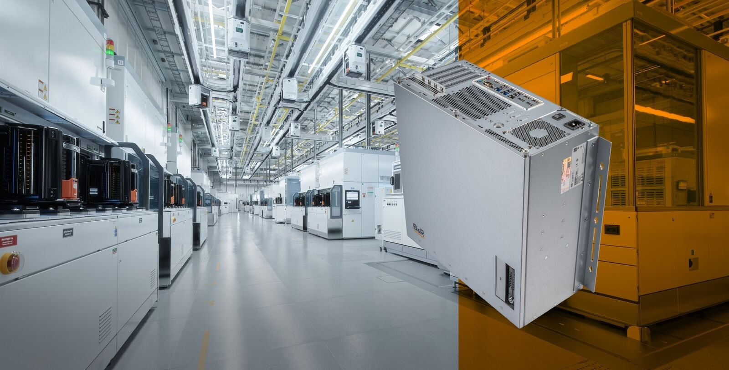
B&R has launched the Automation PC 50A (APC50A). It exhibits exceptional graphics performance and improved scalable architecture to accommodate PCIe extension cards.

About Machine Automation, ABB
ABB’s Machine Automation division delivers automation solutions and services for machine and factory applications across industries such as consumer packaged goods, printing, life sciences, plastics, energy and maritime. With its B&R’s product portfolio, the division delivers integrated control and software, motion control, mechatronics, and machine automation technologies designed to simplify processes and optimize factory operations.

