Merged Human-Machine Interface/controller cuts variant complexity and inventory costs
The Power Panel C650 from B&R Industrial Automation is a high-performance Human-Machine-Interface (HMI), optimized for applications where cost and resource management are high priorities. It delivers advanced functionality and responsiveness systems that may not require or support high end hardware. This makes it ideal for a wide range of industrial use cases that require simplicity, usability and performance.

Eggelsberg/Nuremberg - As well as offering faster processing and smoother graphics, the Power Panel C650 provides multiple communication options in every panel size and supports modern interfaces such as OPC UA FX, as well as Powerlink, X2X and CAN. In this way, the Power Panel C650 closes the gap between legacy panels and modern performance needs. Like all products in the Power Panel range, the C650 incorporates Automation Runtime in a single device. Automation Runtime is a powerful software kernel that runs machine-centric applications on B&R hardware. Functioning both as a real-time operating system and an industrial controller offers a variety of benefits, especially for small-to medium-scale automation projects. It is more cost-effective and efficient compared to using separate components and thus can lead to lower hardware costs and reduced installation costs.
Our new Power Panel C650 combines high-performance control and HMI in one sleek device, delivering faster processing, scalable design, and a premium user experience for cost-efficient industrial automation,” said Serdar Aysu, Product Manager Industrial PCs and Panels at B&R Industrial Automation.
The visualization software mapp View from B&R automation engineers have all the tools they need to create powerful, intuitive, HMI screens on the Power Panel C650. This technology is encapsulated in widgets, which are simply dragged and dropped into place and configured. Creating user interfaces on the Power Panel C650 does not require any additional technical knowledge beyond what is already needed for working with the visualisation environment, making the engineering process straightforward and accessible for developers familiar with the platform.
mapp View is part of the mapp Technology software framework. Modular, pre-programmed software components known as "mapps" – substantially reduce the time and cost of developing automation software. The intelligent mapps communicate with each other automatically – even further reducing the amount of programming required. The extensive mapp portfolio is growing all the time.
The Power Panel C650 integrates HMI functionality with real-time control in a single device, reducing hardware complexity and installation effort. Its support for modern communication standards and mapp-based engineering ensures efficient development and compatibility across diverse automation environments.
About B&R
B&R, a division of ABB Group, is a global leader in industrial automation headquartered in Austria. B&R combines state-of-the-art technology with advanced engineering to provide customers in virtually every industry with complete solutions for machine and factory automation, motion control, HMI and integrated safety technology. With Industrial IoT communication standards including OPC UA, POWERLINK and openSAFETY as well as its Automation Studio software, B&R is constantly redefining the future of automation engineering. The innovative spirit that keeps B&R at the forefront of industrial automation is driven by a commitment to simplifying processes and exceeding customer expectations.
For more information, visit www.br-automation.com

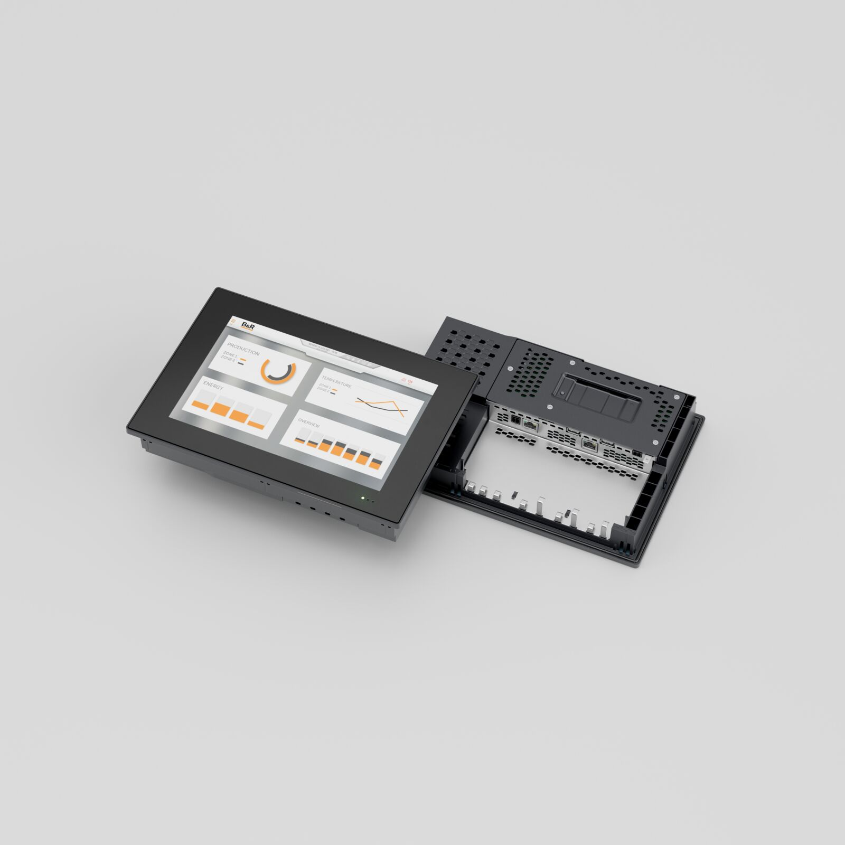
The Power Panel C650 from B&R Industrial Automation is a high-performance Human-Machine Interface (HMI), optimized for applications where cost and resource management are high priorities.

About Machine Automation, ABB
ABB’s Machine Automation division delivers automation solutions and services for machine and factory applications across industries such as consumer packaged goods, printing, life sciences, plastics, energy and maritime. With its B&R’s product portfolio, the division delivers integrated control and software, motion control, mechatronics, and machine automation technologies designed to simplify processes and optimize factory operations.

