B&R to Present Flexible Automation Solutions for Laboratory Operations at SLAS 2026
Fast and flexible lab automation at scale

Boston, MA, February 9-11, 2026 - B&R Industrial Automation, ABB’s Machine Automation division, will present innovative technologies for automation in laboratory environments at SLAS 2026, taking place from February 9 to 11 in Boston, Massachusetts. At Booth 2432, the company will highlight ACOPOS 6D, a magnetic levitation transport system designed for precise and adaptable sample handling.
ACOPOS 6D moves shuttles freely on a planr surface with six degrees of motion. The system supports cleanroom suitable transport and provides high positioning accuracy. Laboratories can increase processing density and reduce overall floor space while maintaining consistent quality in their production. ACOPOS 6D can be integrated with commercial instruments and custom workstations to support continuous end-to-end automation.
Key features on display at B&R’s booth:
• Sample handling with magnetic levitation: The system provides contact-free, contamination resistant movement. Laboratories can support both single sample runs and high throughput sequences.
• Unified automation platform: The integrated system provides real-time data collection and complete traceability through LIMS systems.
• Precision control for consistent results: Motion performance supports accuracy at scale and reliable throughput.
B&R will also highlight how these technologies support high throughput, flexibility, and consistent laboratory performance at scale.
“We are pleased to take part in SLAS 2026 and present our solutions for laboratory applications,” said Lazaros Patsakas, Industry Segment Manager for Life Sciences at B&R. “Our technologies are designed to help laboratory teams achieve high productivity, increased flexibility, and consistent quality.”
About B&R
ABB’s Machine Automation division drives machine and factory automation for the consumer-packaged goods, printing, life sciences, plastics, energy, and maritime industries.
B&R’s portfolio combines state-of-the-art technology with state-of-the-art engineering to provide customers with complete solutions for machine and factory automation, motion control, mechatronics and software. Through comprehensive B&R solutions and services, Machine Automation simplifies customer processes and consistently exceeds customer expectations.
For more information, visit www.br-automation.com.

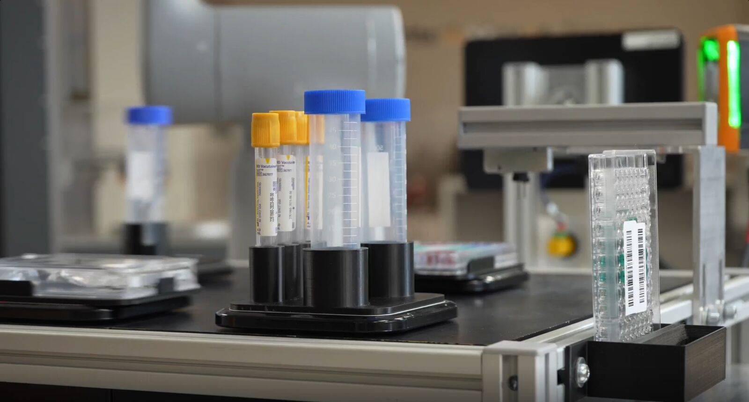
Highlighting the power of adaptive automation with B&R’s ACOPOS 6D, Vision technology, and the ABB GoFa robot working together to achieve greater productivity in a compact, flexible footprint.

About B&R
B&R, a division of ABB Group, is a global leader in industrial automation headquartered in Austria. B&R combines state-of-the-art technology with advanced engineering to provide customers in virtually every industry with complete solutions for machine and factory automation, motion control, HMI and integrated safety technology. With Industrial IoT communication standards including OPC UA, POWERLINK and openSAFETY as well as its Automation Studio software, B&R is constantly redefining the future of automation engineering. The innovative spirit that keeps B&R at the forefront of industrial automation is driven by a commitment to simplifying processes and exceeding customer expectations.
For more information, visit www.br-automation.com.

