Shaping the future of packaging
ABB’s Machine Automation division will showcase adaptive automation solutions for the packaging industry at Interpack
Eggelsberg/Dusseldorf, February 16, 2026 – ABB’s Machine Automation division will showcase a comprehensive range of solutions built on B&R’s technology for the packaging industry at Interpack 2026. A comprehensive portfolio of hardware and software for control, motion, HMI, safety and mechatronics, combined with open connectivity and seamless integration of new technologies such as image processing and simulation, will be among the highlights presented in hall 6, booth E62.
Rapid rise of omnichannel commerce, combined with stricter sustainability regulations and a shifting workforce, is pushing manufacturers, distribution centers, and logistics warehouses to overhaul their packaging and material handling strategies. Companies must now manage not only traditional pallet based retail fulfillment but also highly individualized, small-batch ecommerce orders – all while meeting new environmental requirements such as the EU’s Packaging and Packaging Waste Regulation (PPWR).
Machine Automation division’s solutions for the packaging industry, built on B&R’s technology, enable packaging manufacturers to adapt to new products, personalize at scale, and maximize productivity with intelligent, future‑ready automation designed for an increasingly dynamic consumer packaged goods (CPG) market.
The solutions displayed on site include:
• All Adaptive Demo showcases flexible, modular and adaptive production of the future. It brings together state-of-the-art automation technologies in an interactive demonstrator that realistically depicts various processes and applications for the packaging industry. At the heart of the demo are the ACOPOStrak and ACOPOS 6D transport systems, which enable highly dynamic, single-product and freely configurable product movement. The system is supported by a Codian delta robot that transfers products between platforms, as well as a vision system with two cameras for position detection, quality inspection, and image evaluation. In an industry where versatility and coordinated performance across sorting, transport, robot handling, visual inspection and complete process integration is crucial, this demo highlights the practical value of adaptive and interactive concepts.
• ABB Machine Automation will present its latest ACOPOS 6D solutions, based on B&R’s planar technology, demonstrating a new level of fully adaptive, contact‑free product handling with small machine footprint. By combining cost‑efficient conveyor technology with the magnetic‑levitation ACOPOS 6D planar platform, the system enables manufacturers to reduce costs per Stock Keeping Unit (SKU), increase SKUs per minute, and reach profitability faster. Powered by B&Rs most advanced planar software platform, ACOPOS 6D delivers micron‑level accuracy, zero mechanical wear, fast commissioning and zero‑downtime product changeover. In addition, cleanroom product handling is effectively managed with the 6D planar solution and the Codian SCARA robot mechanics. Booth visitors will be able to experience the future of production through simultaneous, parallel manufacturing of multiple products on a single machine, along with seamless interaction with robots, vision systems or other devices. They will also be able to see how easy it is to simulate, optimize, and diagnose a high-tech industrial transport system with B&R’s integrated technology offering.
• With years of proven performance in CPG applications, ACOPOStrak has become the trusted standard in B&R’s technology portfolio for handling high‑mix, fast‑changing SKU environments with unmatched speed, flexibility, and precision. The new upgrade is equipped with Compact Curve, meaning high‑density layouts in a slim 330 mm footprint for the smallest machine footprint and Metal‑to‑Metal Shuttles and Guides (M2M) for higher payloads including demanding payload positioning and still capable of maximum dynamic, based on that a new level of archivable mass flow per square meter.
• The Open Robotics workstation will showcase how an open robotic platform can deliver high performance operation in demanding applications such as high‑speed pick-and-place, while significantly reducing system complexity. B&R’s open robot mechanics solutions allow Codian robot mechanics to be integrated with solutions from other automation suppliers, enabling an interoperable approach. When paired with B&R control technology, the robot mechanics can be synchronized with sub‑microsecond precision and tightly integrated with motion axes, track systems, and machine vision. Instead of relying on multiple controllers and fragile handshake communication between robots, machines and vision systems, with B&R technology, everything is merged into one control architecture. This demo will show how openness in both software and mechanics removes the barriers of traditional robot integration, enabling manufacturers to scale performance, boost flexibility and streamline machine design – within a single automation platform.
Machine Automation division’s flexible, modular automation platform and mechatronic solutions are designed for today’s production realities, enabling rapid reconfiguration for diverse order profiles and integrating data-driven intelligence to optimize throughput. These systems help manufacturers and distributors remain competitive by increasing agility, reducing waste, and supporting their ability to meet evolving consumer expectations for speed, customization, and environmental responsibility.
About Machine Automation, ABB
ABB’s Machine Automation division delivers automation solutions and services for machine and factory applications across industries such as consumer packaged goods, printing, life sciences, plastics, energy and maritime. With its B&R’s product portfolio, the division delivers integrated control and software, motion control, mechatronics, and machine automation technologies designed to simplify processes and optimize factory operations.

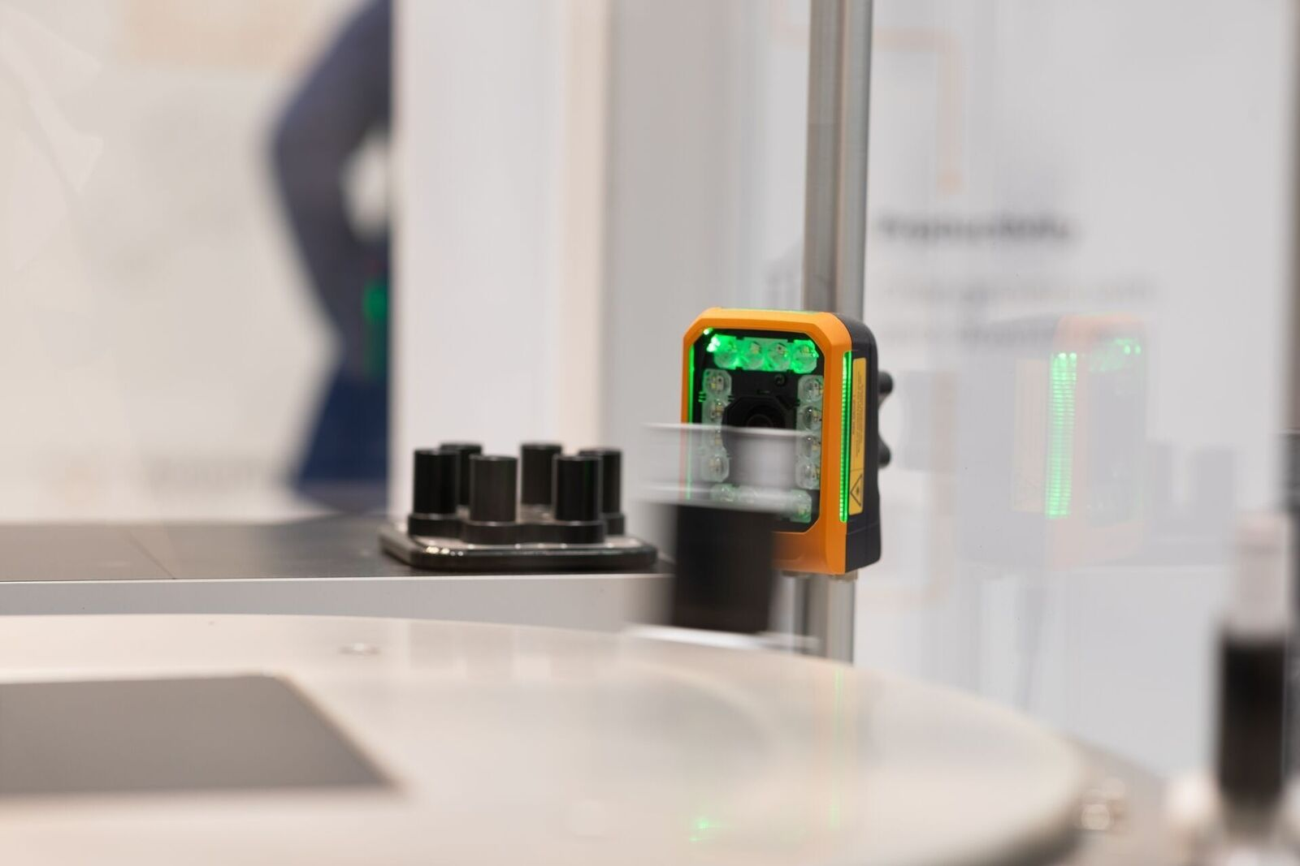
ABB’s Machine Automation division will showcase a comprehensive range of solutions built on B&R’s technology for the packaging industry at Interpack 2026

About Machine Automation, ABB
ABB’s Machine Automation division delivers automation solutions and services for machine and factory applications across industries such as consumer packaged goods, printing, life sciences, plastics, energy and maritime. With its B&R’s product portfolio, the division delivers integrated control and software, motion control, mechatronics, and machine automation technologies designed to simplify processes and optimize factory operations.

