ABB Machine Automation (B&R) appoints Stefan Schönegger as Chief Technology Officer (CTO)

Stefan joined Machine Automation in 2006 as Project Manager PLC and Control Systems. He has since held various leadership roles, including Head of Product Management, and as of 2022, he has been leading the Global Product Group Controls. Stefan has extensive, long-term experience in B&R technology, deep understanding of customer needs and strong connections to industry partners. His proven track record in building highly effective organizations will be a solid foundation for leading the CTO organization.
“I’m looking forward to the new opportunity within B&R. With our teams we will be advancing our technology vision across automation, software, and autonomous industrial solutions. Open eco-systems and partnerships will be at the center of many activities”, he says. Stefan holds a degree in Electronics & Business from University of Applied Sciences Vienna and a postgraduate degree in Renewable Energy Systems from Technical University of Vienna.
Stefan Schönegger succeeds Florian Schneeberger, who is leading Machine Automation division as of November 1, 2025, as Division President and CEO of B&R Industrial Automation.

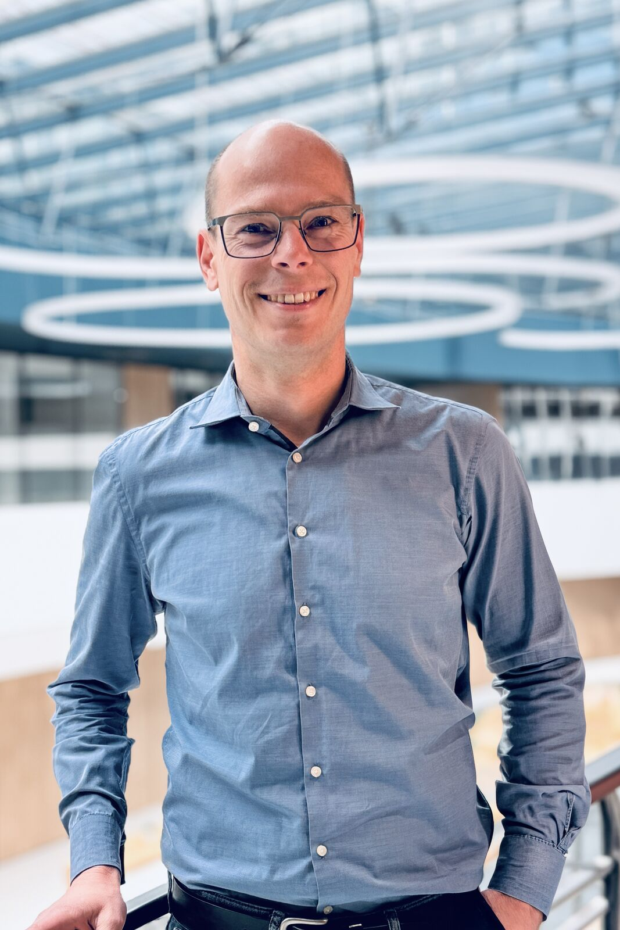
ABB Machine Automation division appoints Stefan Schönegger as Head of Technology (CTO)

About Machine Automation, ABB
ABB’s Machine Automation division delivers automation solutions and services for machine and factory applications across industries such as consumer packaged goods, printing, life sciences, plastics, energy and maritime. With its B&R’s product portfolio, the division delivers integrated control and software, motion control, mechatronics, and machine automation technologies designed to simplify processes and optimize factory operations.

