TÜV Rheinland confirms B&R’s CRA Guide for POWERLINK
Verified implementation guideline for OEMs and system integrators
The EU Cyber Resilience Act (CRA) will require new security standards for connected products starting at the end of 2027. B&R is supporting its customers with a comprehensive guideline: the “B&R CRA Guide for POWERLINK” provides transparent insights into the secure operation of POWERLINK‑based systems. The implementation guideline has been reviewed by TÜV Rheinland, making it one of the first independently audited technical documents addressing the requirements of the Cyber Resilience Act in the automation industry.
OEMs and system integrators benefit from a practical, hands‑on resource that significantly reduces their implementation effort. In addition to clear recommendations for action and supporting arguments, the B&R guide includes security and architecture concepts that ensure secure and CRA-compliant integration of POWERLINK.
“Transparency is of utmost importance to us when it comes to Cyber Security. Simply stating CRA compliance is not enough for us. System integrators need a concrete roadmap. With the publication of our CRA Guide, we’re taking an active role in advancing Cyber Security across the automation industry. Our aspiration is to be a reliable and strong partner for our customers while making a meaningful contribution to sustainably strengthening Cyber Security across the European market,” said Stefan Schönegger, CTO, ABB’s Machine Automation division (B&R).
Product and software development according to IEC 62443
The CRA guide is based on B&R’s many years of expertise in Cyber Security. The entire B&R product development process is certified according to IEC 62443‑4‑1. Especially in software development, the automation specialist has already reached Maturity Level 3. This confirms that B&R incorporates Cyber Security considerations into every phase of product development – from specification and design to implementation, testing, and maintenance.
Practical guide to CRA requirements
The CRA guide is based on B&R’s many years of expertise in Cyber Security. The entire B&R product development process is certified according to IEC 62443‑4‑1. Especially in software development, the automation specialist has already reached Maturity Level 3. This confirms that B&R incorporates Cyber Security considerations into every phase of product development – from specification and design to implementation, testing, and maintenance.
The B&R CRA Guide for POWERLINK is now available for free download on the B&R website.
Download B&R CRA-Guide für POWERLINK

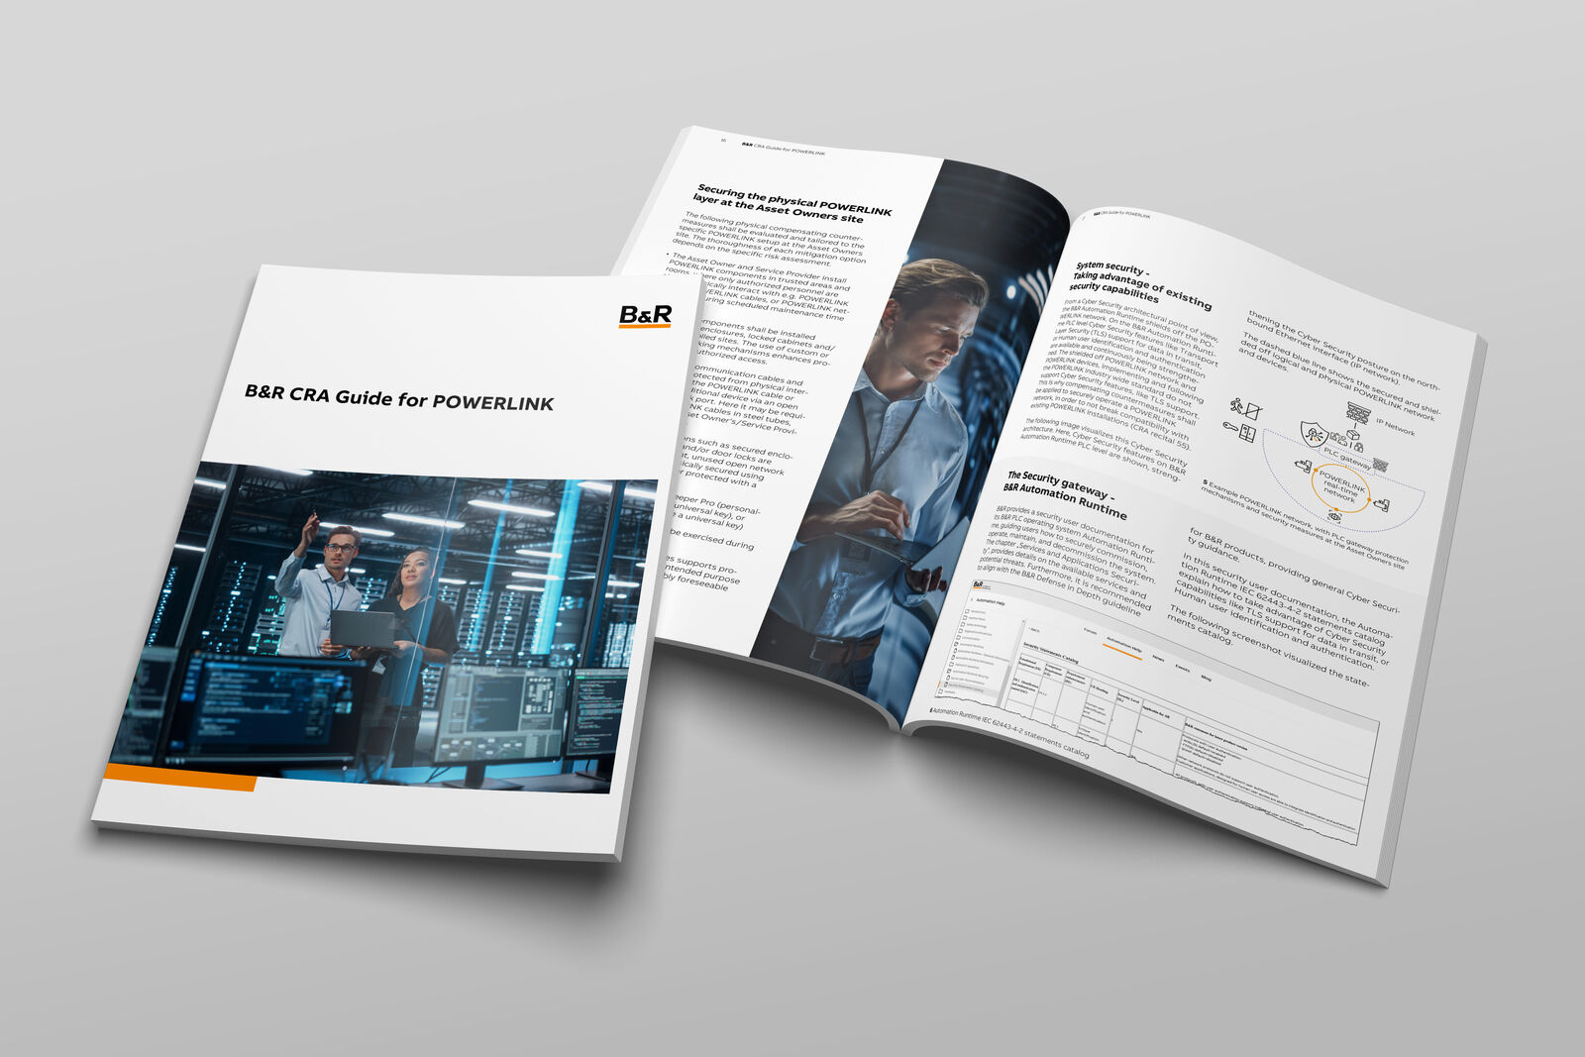
TÜV Rheinland confirms B&R’s CRA Guide for POWERLINK

About Machine Automation, ABB
ABB’s Machine Automation division delivers automation solutions and services for machine and factory applications across industries such as consumer packaged goods, printing, life sciences, plastics, energy and maritime. With its B&R’s product portfolio, the division delivers integrated control and software, motion control, mechatronics, and machine automation technologies designed to simplify processes and optimize factory operations.

