Closed-loop vision ensures scrap-free print production
B&R introduces Color Camera for high-speed RGB print mark detection
With the new B&R Color Camera, ABB’s Machine Automation division introduces precise print mark detection to OEMs and machine builders. Designed to balance color accuracy and high-speed processing, the new vision solution delivers reliable results under demanding conditions and at full line rate. The innovation was introduced at Chinaplas 2026.
Closed-loop vision at production speed
The B&R Color Camera is designed to fundamentally improve key production metrics and to support first-time-right printing. By enabling immediate, vision-based process corrections at production speeds up to 500 m/min, the new color vision solution helps reduce waste of materials directly at the source, cutting costs as a result. Integrated into the machine control loop, the camera provides real-time feedback, contributing to higher overall equipment effectiveness while also supporting more sustainable printing processes.
“Our new Color Camera brings printers a decisive step closer to autonomous vision systems. Major industry transformations like frequent design changes and modern packaging made of glossy, transparent, and multi-colored materials make reliable print mark detection particularly demanding. When print marks cannot be detected consistently, scrap and material waste increase, which directly impacts margins. With our new Color Camera, we tackle these challenges,” said Pieter Prinsloo, Global Product Manager, Machine Vision at ABB’s Machine Automation division.
Intelligent adaptive algorithms
The B&R Color Camera comes with an auto-exposure functionality, adapting exposure time and contrast during operation. This keeps the printing process running without manual tuning stops and helps prevent scrap through continuous adjustment to changing materials and print designs. Unlike standalone vision sensors that communicate asynchronously with machine controllers, B&R Color Camera integrates vision, motion, and control on a single deterministic platform, preventing latency, jitter, and synchronization issues. This tight integration enables microsecond-level synchronization and real-time, in-cycle corrections.
“We are making vision an integral part of the process. Our Color Camera is native to the machine control system. This means we deliver a complete printing solution – one that enables a higher level of autonomy,” said Pieter Prinsloo.
One platform for monochrome and color
The B&R Color Camera supports both monochrome and color image applications on a single hardware platform. This unified approach simplifies machine design and enables easy scaling to color applications within B&Rs Automation Studio. For OEMs and end users, this means the flexibility to choose between monochrome or color functionality as required – without additional hardware complexity or extra costs. The one‑platform approach also accelerates engineering and commissioning. Throughout the entire lifecycle of the vision solution, a single software environment – mapp Vision – ensures that applications remain easy to create, configure, and maintain.

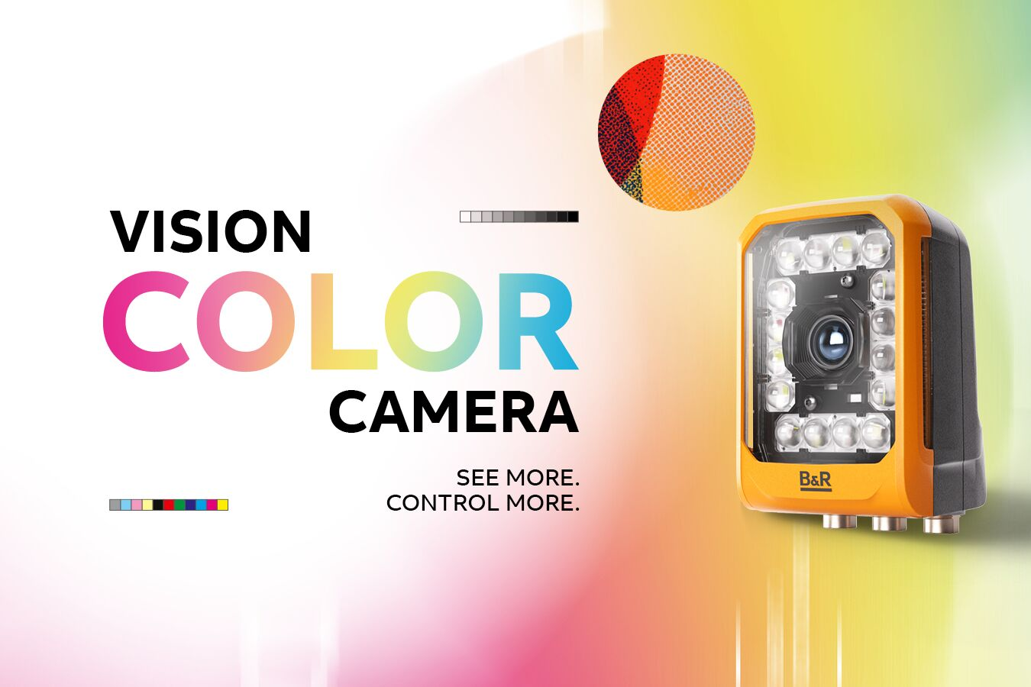
With the new B&R Color Camera, ABB’s Machine Automation division introduces precise print mark de-tection to OEMs and machine builders.

About Machine Automation, ABB
ABB’s Machine Automation division delivers automation solutions and services for machine and factory applications across industries such as consumer packaged goods, printing, life sciences, plastics, energy and maritime. With its B&R’s product portfolio, the division delivers integrated control and software, motion control, mechatronics, and machine automation technologies designed to simplify processes and optimize factory operations.

