Packaging gets personal: machine automation innovations at Interpack 2026
B&R introduces new vision and mechatronics solutions for more autonomous packaging production
Packaging requirements are increasing rapidly: more product variants, tighter timelines and shorter product lifecycles are placing growing demands for packaging operations. At Interpack 2026, ABB’s Machine Automation division is addressing these challenges by introducing new automation solutions based on B&R technology designed to enable manufacturers adapt existing packaging lines more quickly, efficiently and sustainably. Visitors can experience the new solutions in hall 6, booth E62.
Transport systems beyond mechanics
With ACOPOS 6D Hybrid, B&R further expands the flexibility of its planar transport system and complements it with ACOPOS 6D LaunchPad, a software tool for simulation-based engineering and configuration. The hybrid concept combines magnetically levitated ACOPOS 6D shuttles for high-value process steps with conventional transport systems such as conveyors, robots or other manipulators for less critical tasks, all coordinated within a single control architecture. Using ACOPOS 6D LaunchPad, machine layouts, shuttle flows and process sequences can be designed, simulated and optimized virtually before hardware is installed, allowing manufacturers to validate performance, reduce commissioning time and scale systems step by step as requirements evolve. Once the hardware becomes available, the transition from simulation to reality is seamless: thanks to the “Configure and Run” approach, the virtual setup can simply be transferred to real hardware. The result is a reduction in engineering effort, fewer late-stage changes, and a faster time-to-market, turning virtual engineering into a decisive competitive advantage.
Integrated Color Vision ready-to-use for packaging
The new B&R Color Camera improves key printing performance indicators by enabling vision‑based process corrections at production speeds of up to 500 m/min. Integrated directly into the machine control loop, the solution supports first‑time‑right printing, reduces material waste at the source and increases overall equipment effectiveness, contributing to more sustainable and cost‑efficient printing processes. Designed for modern packaging and printing applications, such as labeling, with frequent design changes and challenging materials, e.g., glossy, transparent and multi-colored substrates, the Color Camera enables autonomous process optimization. Intelligent adaptive algorithms, including autoexposure, continuously adjust to changing conditions without manual intervention, helping to prevent scrap. Unlike standalone vision systems, the B&R Color Camera integrates vision, motion and control on single deterministic platform, enabling real-time, in-cycle corrections with microsecond-level synchronization. A unified hardware and software platform supports both monochrome and color applications, simplifying machine design, accelerating commissioning and allowing scalable vision functionality within a single engineering environment.
“Our innovations here at Interpack highlight that we aim to enable the packaging industry to respond to the most pressing challenges: fast turnovers, constantly new variants, and an overall maximized productivity– so packaging can get personal,” said Lazaros Patsakas, Global Industry Segment Manager CPG at B&R. “These challenges can only be solved with intelligent, future‑ready automation.”

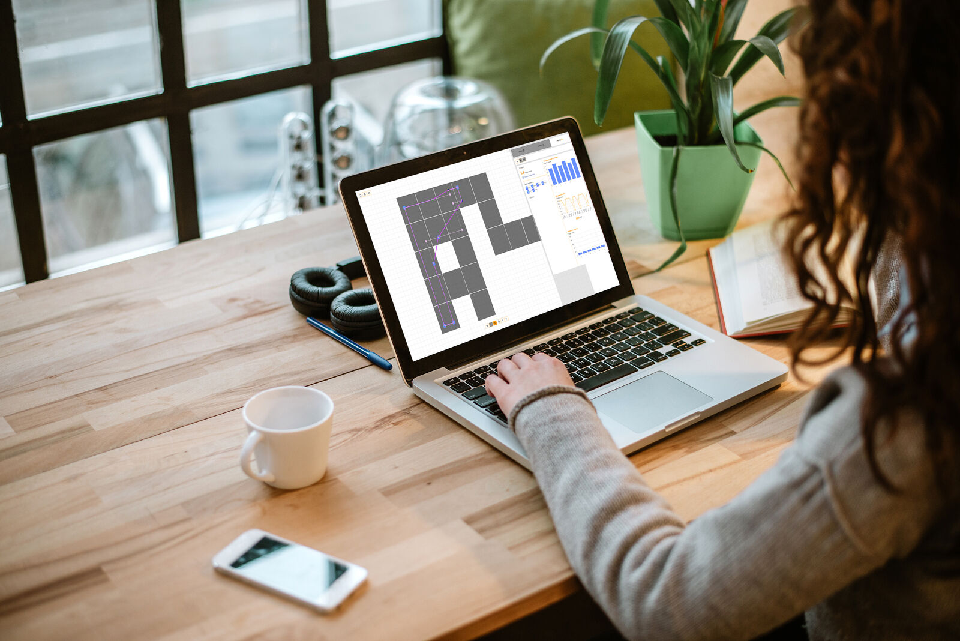
B&R’s newest innovations in vision and mechatronics solutions for the packaging industry
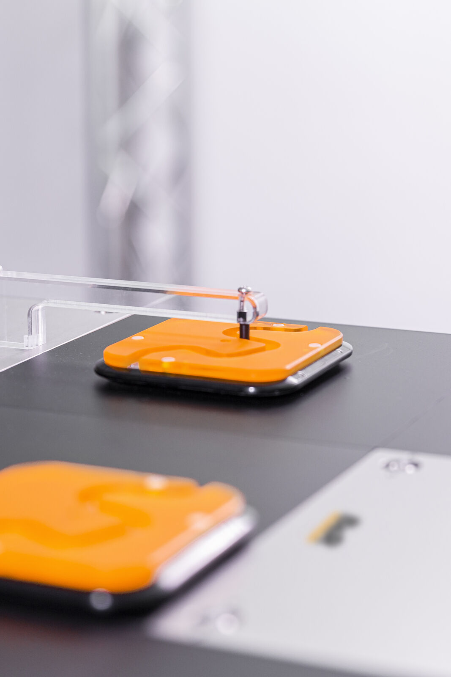
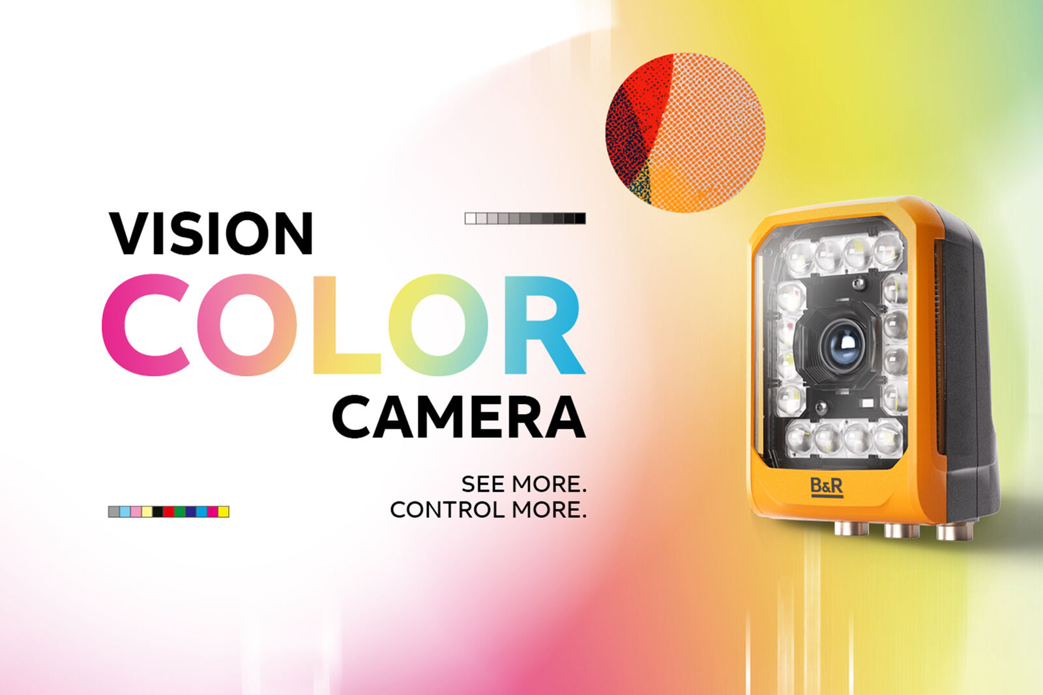

About Machine Automation, ABB
ABB’s Machine Automation division delivers automation solutions and services for machine and factory applications across industries such as consumer packaged goods, printing, life sciences, plastics, energy and maritime. With its B&R’s product portfolio, the division delivers integrated control and software, motion control, mechatronics, and machine automation technologies designed to simplify processes and optimize factory operations.

