Salzburg University and ABB’s Machine Automation Division (B&R) Collaborate to Advance AI-Enabled Energy Optimization in Industrial Motion Control
Salzburg University of Applied Sciences and ABB’s Machine Automation Division (B&R) are working together to apply artificial intelligence (AI) to improve energy efficiency in industrial automation.
The collaboration, anchored in the Josef Ressel Center for Intelligent and Secure Industrial Automation (JRZ ISIA), focuses on translating advanced research into practical solutions for industrial drive systems.
A recent milestone of this collaboration is the filing of a joint patent application in the field of energy‑optimized motion control for drive systems used in industrial automation – such as robots, machine tools and automated production lines – where highly dynamic motion sequences including positioning, acceleration, deceleration and cyclic movement must be controlled with high precision. The development reflects ongoing efforts to bridge academic research and industrial application.
The collaboration addresses a known challenge in industrial automation. While conventional control methods rely on increasingly accurate mathematical models, they don’t always fully capture real‑world energy losses that can be measured but cannot be precisely modeled or described in detail.
To address this limitation, the collaboration explores applying AI – in particular reinforcement learning (RL) methods that can learn directly from real system behavior. A learning agent, deployed on the physical system, interacts with the machine and autonomously learns how different motion profiles contribute to energy losses, adapting the control strategy accordingly, without requiring a complete system model.
A key innovation of the work lies in a new mathematical formulation of the learning strategy, which enables faster learning with reduced data requirements. This allows reinforcement learning methods – traditionally considered too slow and data‑intensive for industrial use – to be applied more effectively in industrial environments while delivering improved results. As a result, deployment in cyber‑physical systems becomes economically and technically viable, with the goal of making motion sequences substantially more energy‑efficient while fully reflecting real operating conditions.
“The collaboration and the resulting patent filing clearly demonstrate how scientific excellence and industrial practice come together at the Josef Ressel Center. Our aim is to ensure that research does not stop at the laboratory, but results in tangible technological innovations for industry,” said Stefan Huber, Head of Research at Salzburg University of Applied Sciences. “In the field of artificial intelligence in particular, Austria and Europe need research at the technological forefront that delivers direct impact on industrial value creation.”
“Close cooperation with Salzburg University of Applied Sciences allows us to bring innovative research methods into practical industrial applications at an early stage,” said Martin Haidacher, Innovation Manager at B&R. “It highlights the value of combining academic research with industrial expertise to advance the development of solutions that deliver value in real-world applications.”
The underlying research builds on several years of development. Initial work dates back to 2020, when the topic was launched within the EU Interreg project KI‑Net. Since 2022, the research has been further developed within the Josef Ressel Center in collaboration with industry partners from ABB’s Machine Automation Division (B&R), COPA‑DATA and others.

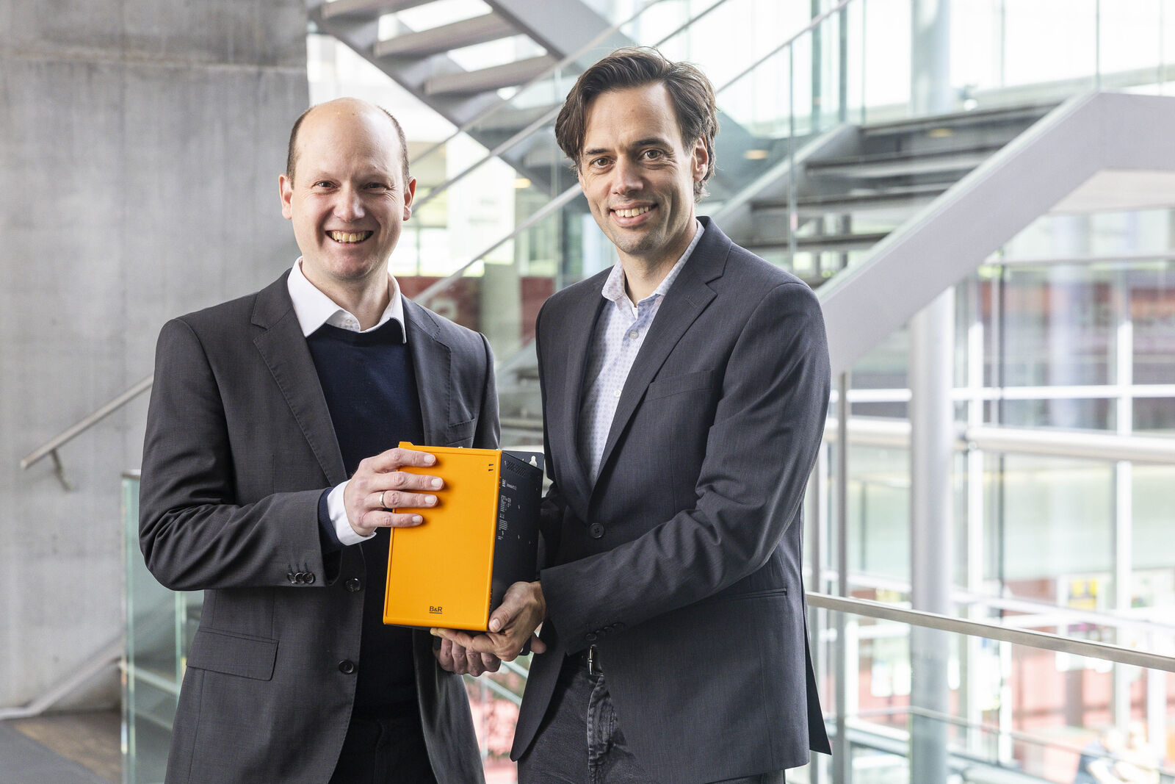
Stefan Huber (Head of Research, FH Salzburg) and Martin Haidacher (Innovation Manager, B&R)

About Machine Automation, ABB
ABB’s Machine Automation division delivers automation solutions and services for machine and factory applications across industries such as consumer packaged goods, printing, life sciences, plastics, energy and maritime. With its B&R’s product portfolio, the division delivers integrated control and software, motion control, mechatronics, and machine automation technologies designed to simplify processes and optimize factory operations.

