ABB’s Machine Automation division (B&R) appoints Christian Strahberger as Division President
Christian Strahberger brings 25 years of experience in senior leadership roles with full profit and loss responsibility across the mechanical engineering, drive technology, motion control, and power electronics sectors. He joins the Austrian automation specialist from Danfoss, where he held a variety of international leadership positions, most recently serving as Chief Technology Officer and Head of Semiconductor Manufacturing at Semikron Danfoss. Prior to his time at Danfoss, Christian Strahberger spent 14 years in senior technology and business leadership roles at Singulus Technologies, Schottel, and Voith.
“I am very excited about this new challenge at ABB and the opportunity to actively shape the next era of the Machine Automation Division. My focus is on driving innovation with purpose and successfully translating future technologies into market-relevant solutions. Together with our teams, I want to help ensure that B&R continues to enable sustainable competitive advantages for our customers as a trusted partner in a dynamic market environment,” says Christian Strahberger.
In his new role as Division President, Christian Strahberger will focus on driving innovation that helps customers increase their productivity and competitiveness while enabling them to operate more sustainably.
Christian Strahberger holds a PhD in Semiconductor Physics from the Technical University of Munich. His professional career combines scientific excellence with many years of international leadership experience in technology-driven industrial companies, underscoring his commitment to leveraging innovation as a key driver of sustainable growth.

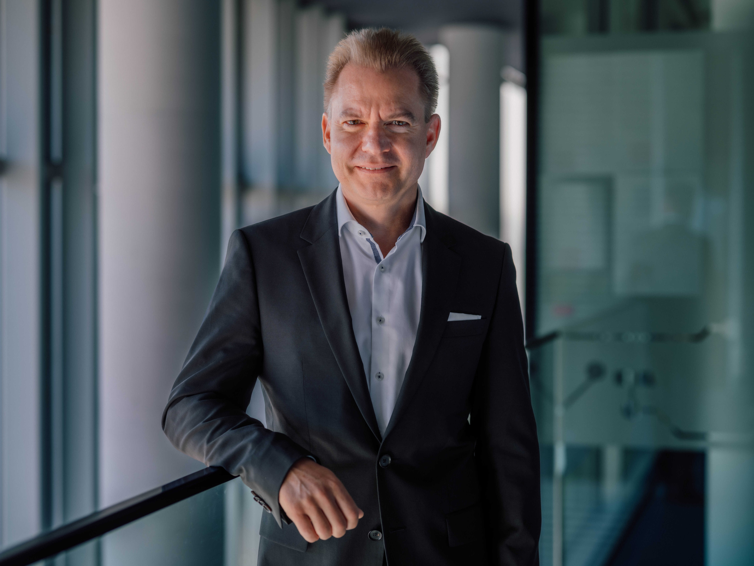
OVERWRITE THIS TEXT Add the media caption here OVERWRITE THIS TEXT

About Machine Automation, ABB
ABB’s Machine Automation division delivers automation solutions and services for machine and factory applications across industries such as consumer packaged goods, printing, life sciences, plastics, energy and maritime. With its B&R’s product portfolio, the division delivers integrated control and software, motion control, mechatronics, and machine automation technologies designed to simplify processes and optimize factory operations.

