Shaping the future of packaging
ABB’s Machine Automation division will showcase adaptive automation solutions for the packaging industry at Pack Expo International 2026.
Chicago, IL October 18-21, 2026 — B&R, a division of ABB and a leader in machine automation, will showcase innovative automation solutions designed to help packaging machine builders and manufacturers increase flexibility, improve performance, and accelerate time-to-market at PACK EXPO International 2026. At booth S-2451, visitors will experience the latest advancements in intelligent motion control, adaptive manufacturing, simulation technologies and hygienic automation solutions for packaging applications.
As packaging manufacturers face growing demands for product variety, shorter production runs, and greater operational efficiency, they must also meet increasingly stringent hygiene and product safety requirements. B&R continues to develop technologies that simplify machine design while delivering the agility needed for today's production environments.
A featured highlight at the booth will be a new compact conveyor demonstration with an integrated diversion system, showcasing how manufacturers can achieve efficient product handling and routing within a smaller machine footprint. The demonstration illustrates how intelligent automation solutions can help packaging operations adapt quickly to changing production requirements while maximizing throughput and maintaining the high standards increasingly expected in food, beverage and consumer goods production.
From concept to commissioning with digital simulation
B&R helps machine builders accelerate development and reduce project risk through advanced simula- tion and virtual engineering tools. With ACOPOS 6D LaunchPad, manufacturers can design, simulate and optimize machine layouts, transport flows and production scenarios before hardware is installed. By testing concepts in a virtual environment, machine builders can reduce engineering effort, identify potential issues earlier and accelerate commissioning.
Combined with B&R's unified automation platform, simulation capabilities enable manufacturers to validate machine performance, optimize throughput and shorten time-to-market while reducing development costs.
Integrated automation technologies further enhance machine flexibility by seamlessly coordinating motion control, machine control, product handling and digital engineering tools within a single environment. This enables machine builders to simplify development while achieving higher levels of productivity and adaptability.
Automation ready for changing demands
As packaging operations evolve toward greater product personalization, increased production variability and stricter hygiene requirements, manufacturers require solutions that can adapt quickly with- out sacrificing performance. B&R's portfolio of transport, motion control and automation technologies enables machine builders to create equipment that supports greater flexibility, scalability and operational efficiency.
"Today's packaging manufacturers need automation that can respond quickly to changing production requirements while maintaining maximum productivity," said Lazaros Patsakas, Global Industry Segment Manager CPG at B&R. "At PACK EXPO, we're demonstrating how intelligent transport, product handling and integrated automation technologies help our customers build more adaptable, future- ready packaging operations."
Throughout the event, B&R experts will demonstrate how integrated automation technologies can help manufacturers improve productivity, adapt to changing consumer demands and create packaging solutions that are ready for the challenges of tomorrow's manufacturing environment.
To learn more, visit B&R at Booth S-2451 in the South Building during PACK EXPO International 2026

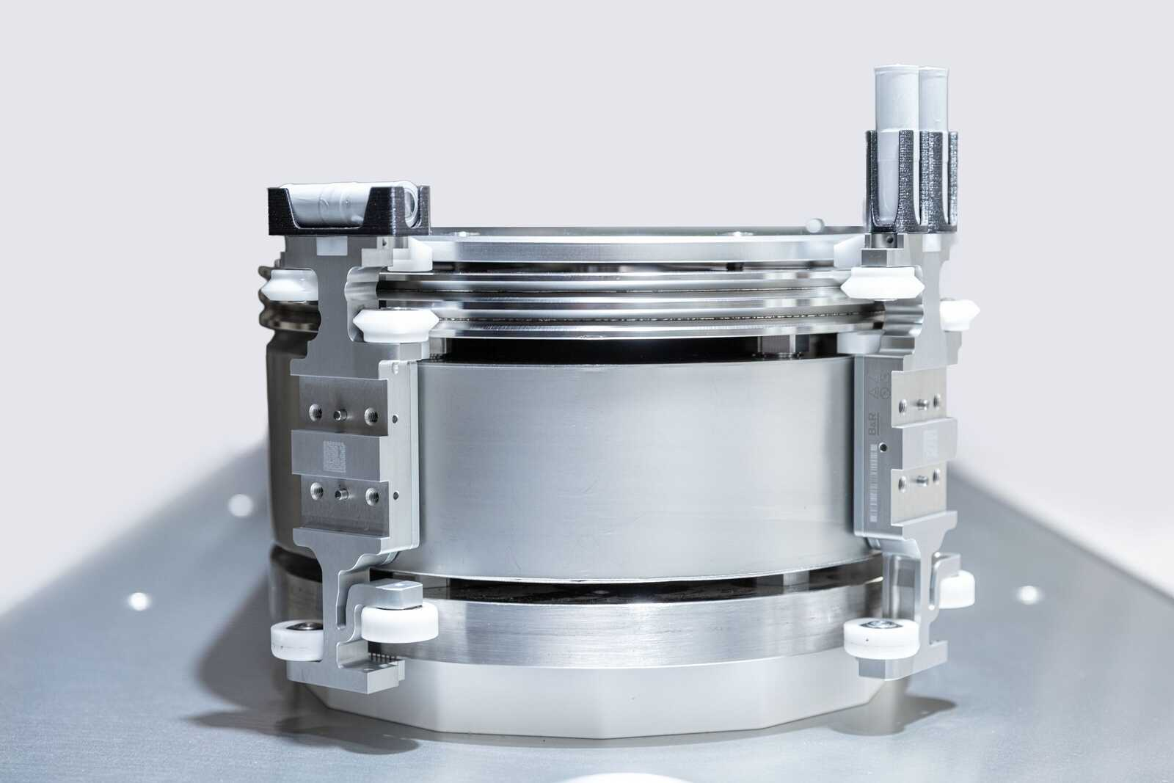
One of the featured highlights at Booth S-2451 is the B&R Compact Curve with diversion, demonstrating flexible product handling and intelligent conveying in a compact footprint. Stop by and see it in action.

About Machine Automation, ABB
ABB’s Machine Automation division delivers automation solutions and services for machine and factory applications across industries such as consumer packaged goods, printing, life sciences, plastics, energy and maritime. With its B&R’s product portfolio, the division delivers integrated control and software, motion control, mechatronics, and machine automation technologies designed to simplify processes and optimize factory operations.

