Redefining Machine Interaction

Designed for ease of use, B&R's new HMI portfolio enables machine builders to create intuitive operating concepts tailored to their specific applications. As HMIs play an increasingly important role in the overall machine user experience, the scalable ecosystem provides the building blocks for intuitive and efficient machine operation.

“With our scalable portfolio of HMIs and automation PCs, open technologies, and long-term lifecycle support, we provide machine builders with a comprehensive package from a single machine to full-scale series production,” says Klemens Sattlegger, Global Product Group Manager HMI / Industrial Computing. “Combined with our visualization software and integrated engineering environment, machine builders benefit from a complete ecosystem.”
New Standards in Performance and Cyber Security
With the APC 40A, B&R introduces a high-performance industrial PC based on AMD processor technology. Its integrated neural processing unit (NPU) delivers up to 50 TOPS of processing performance to support compute-intensive and AI-enabled applications. Integrated security-by-design features help machine builders meet current and future security requirements.
Designed for Smarter Interaction
With the Automation Panel 1500, B&R showcases the next generation of HMI design. A camera, RFID reader, and LED status bar are integrated directly into the panel. Machine builders can customize elements such as logos, labels, and function keys to match individual machine designs, enabling customization down to batch size one.
Integration of mapp View Now Directly on the Hardware
For applications where compactness is a key priority, B&R is expanding its Power Panel portfolio. The Power Panel C650, the first member of the new Power Panel 600 family, combines visualization, control, and engineering within a single, integrated system. With the introduction of mapp View EMB, B&R’s mapp View software is now also available on the Power Panel platform. Machine builders benefit from a consistent engineering approach across different HMI platforms and can implement advanced visualization solutions with lower hardware requirements.
Artificial Intelligence in the HMI
At SPS 2026, B&R will demonstrate how artificial intelligence can simplify machine operation with a new AI Assistant. The solution uses only data from the machine manual and machine controller, providing operators with relevant information directly within the HMI. Because the solution runs on premises, sensitive machine and production data remain under the operator’s control at all times.
SPS 2026
In addition to showcasing the next generation of human-machine interaction, B&R will present numerous other innovations from the world of industrial automation at SPS 2026.
Visit B&R at SPS 2026 in Hall 7, Booth 206
About Machine Automation, ABB
ABB’s Machine Automation division delivers automation solutions and services for machine and factory applications across industries such as consumer packaged goods, printing, life sciences, plastics, energy and maritime. With its B&R’s product portfolio, the division delivers integrated control and software, motion control, mechatronics, and machine automation technologies designed to simplify processes and optimize factory operations.

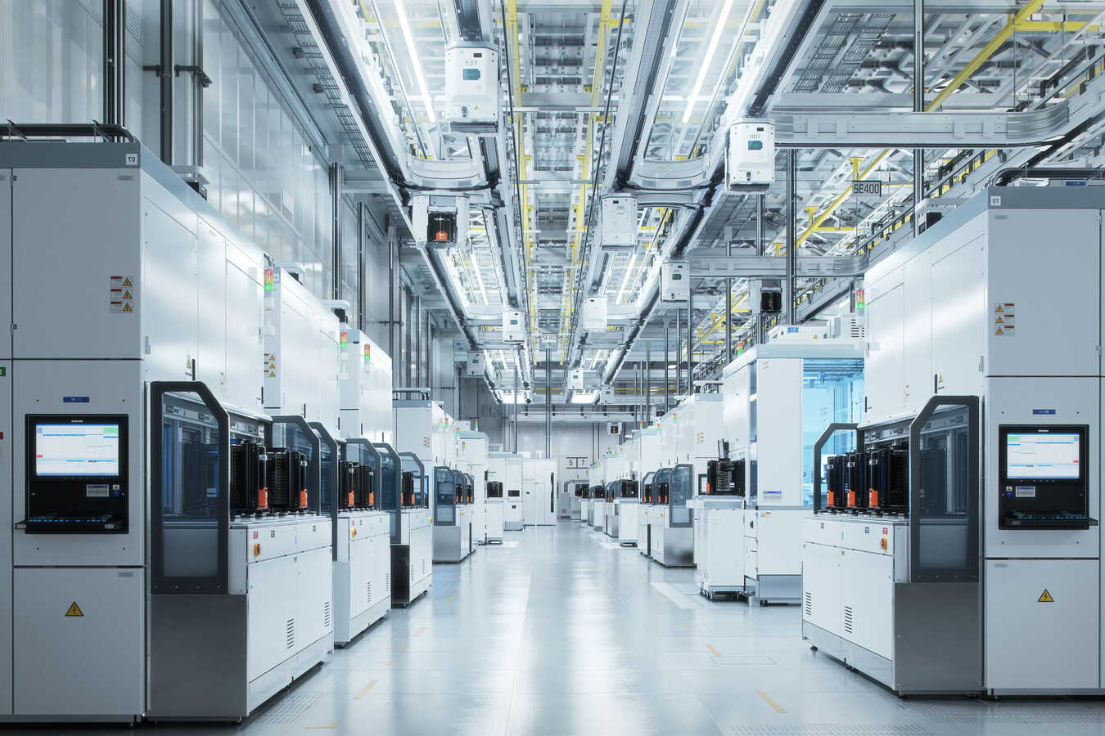
ABB’s Machine Automation division (B&R) introduces the next generation of Human-Machine-Interface (HMI) solutions.

About Machine Automation, ABB
ABB’s Machine Automation division delivers automation solutions and services for machine and factory applications across industries such as consumer packaged goods, printing, life sciences, plastics, energy and maritime. With its B&R’s product portfolio, the division delivers integrated control and software, motion control, mechatronics, and machine automation technologies designed to simplify processes and optimize factory operations.

